Questions

- Get all employees
SELECT * FROM employee;
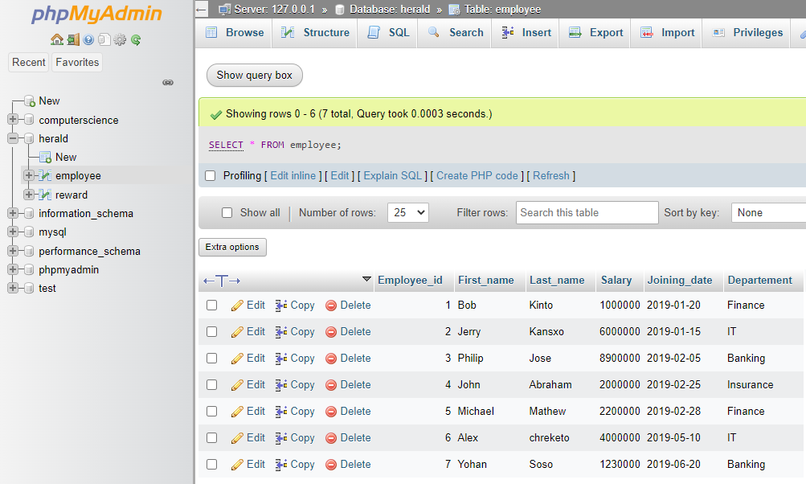
- Display the first name and last name of all employees.
SELECT First_name, Last_name FROM employee;
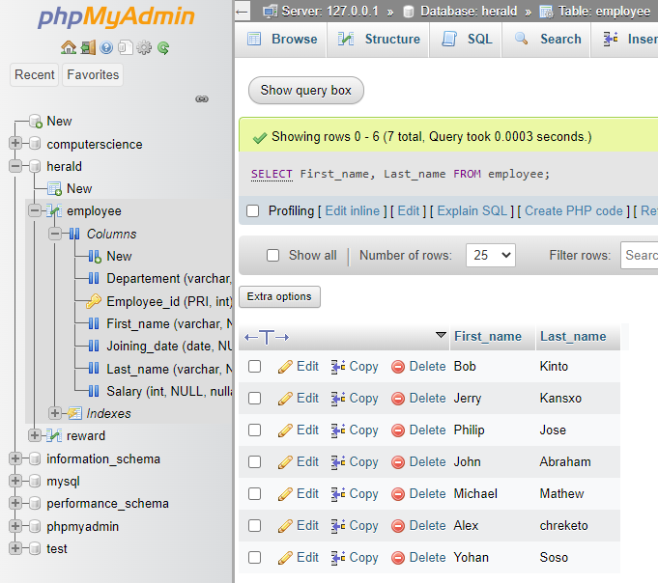
- Display all the values of the “First_Name” column using the alias “Employee Name”
SELECT First_name AS "Employee Name" FROM employee;
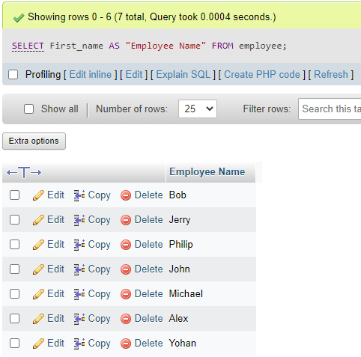
- Get all “Last_Name” in lowercase.
SELECT LOWER(Last_name) FROM employee;
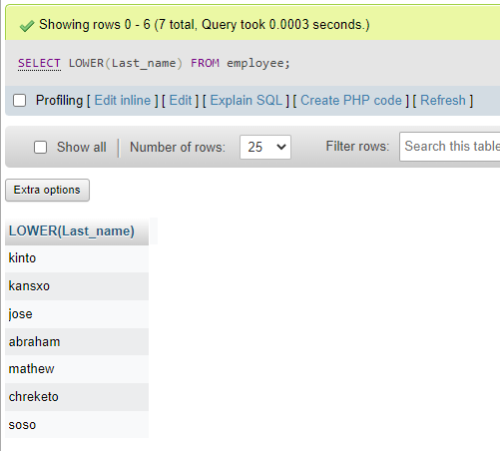
- Get all “Last_Name” in uppercase.
SELECT UPPER(Last_name) FROM employee;
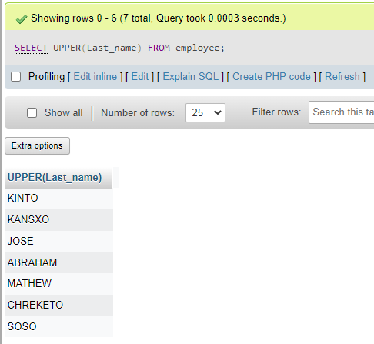
- Get unique “DEPARTMENT”.
SELECT DISTINCT Departement FROM employee;
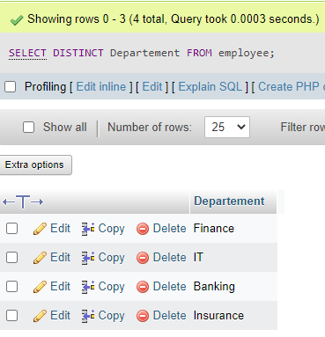
- Get the first 4 characters of “FIRST_NAME” column.
SELECT SUBSTRING(First_name,1,4) FROM employee;
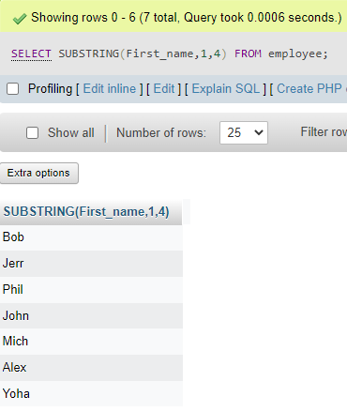
- Get all values from the “FIRST_NAME” column after removing white space on the right.
SELECT RTRIM(First_name) FROM employee;
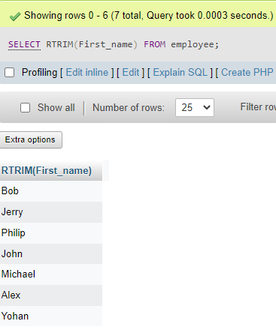
- Get all values from the “FIRST_NAME” column after removing white space on the left.
SELECT LTRIM(First_name) FROM employee;
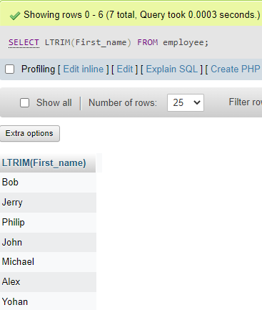
- Write the syntax to create the “employee” table.
CREATE TABLE Employeee (Employee_id int AUTO_INCREMENT PRIMARY KEY, First_name VARCHAR(25), Last_name VARCHAR(25), Salary int, Joining_date Date, Departement VARCHAR(50));
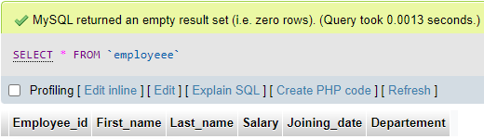
- Get the length of the text in the “First_name” column.
SELECT LENGTH(First_name) FROM employee;
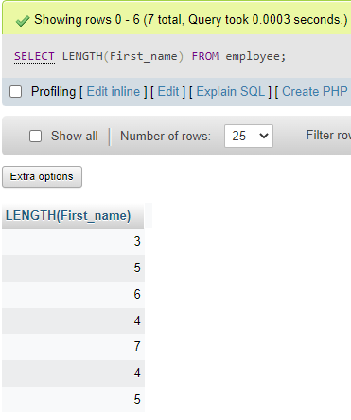
- Get the employee’s first name after replacing ‘o’ with ‘#’.
SELECT REPLACE(First_name,'o','#') FROM employee;
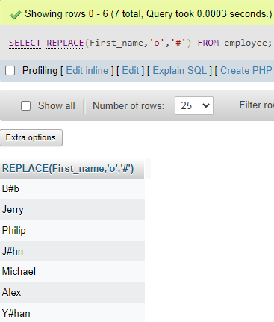
- Get the employee’s last name and first name in a single column separated by a ‘_’.
SELECT CONCAT(First_name,'_',Last_name) FROM employee;
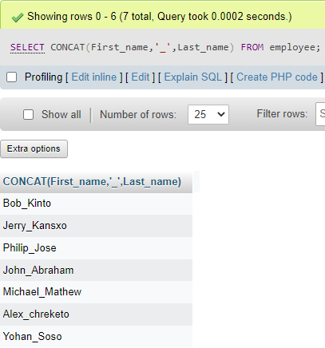
- Get all employees in ascending order by first name.
SELECT * FROM employee ORDER BY First_name ASC;
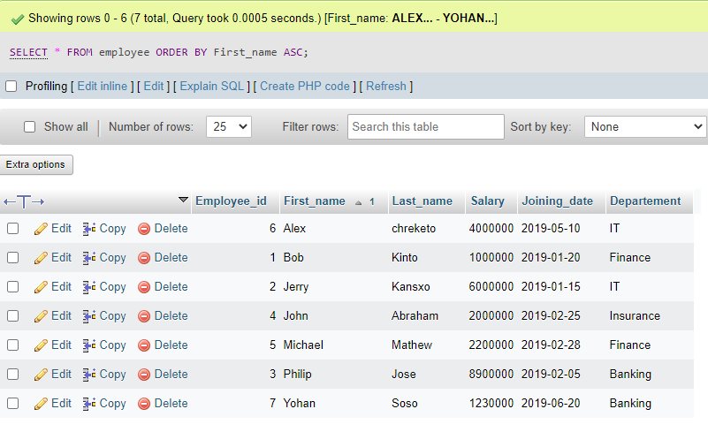
- Get all employees in descending order by first name.
SELECT * FROM employee ORDER BY First_name DESC;
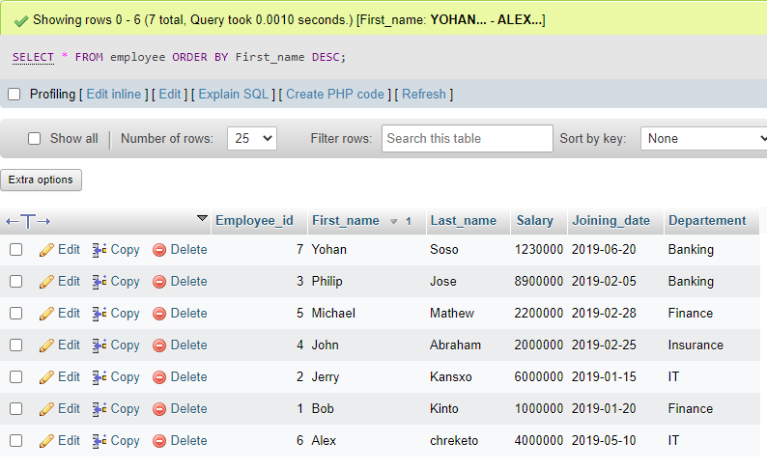
- Get employees whose first name is “Bob”.
SELECT * FROM employee WHERE First_name='Bob';
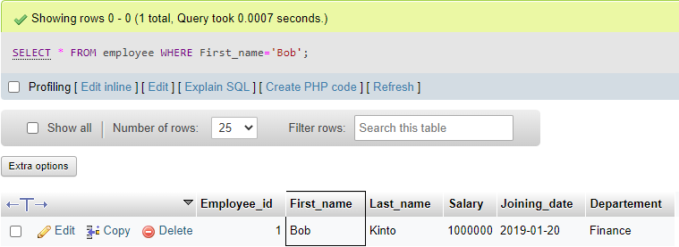

- Get employees whose first name is “Bob” or “Alex”.
SELECT * FROM employee WHERE First_name IN ('Bob','Alex');
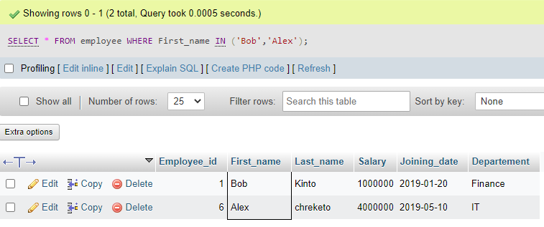
- Get employees whose first name is neither “Bob” nor “Alex”.
SELECT * FROM employee WHERE First_name NOT IN ('Bob','Alex');
